Greetings to you classmates, we wanted to give you a heads up about some things that are happening now and happenings that will take place in the future.

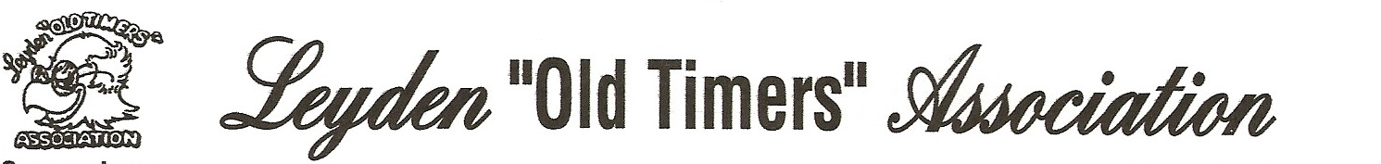

There is an East Leyden Alumni group based in Illinois called Leyden “OLD TIMERS” Association. It’s a no cost group (only pay for activities you participate in) – there are no dues, no officers – no elections – no by-laws – no gender barriers – no rules that can’t be bent……does this sound like Chicago, or what???

The Rules: You must be at least 40 years old and must have had at least one “A” in your 13 years of school Well, we are all over 40 – so we all are eligible and if you never got *even one* “A” that’s where the rules get bent.

The group started in 1986 when Ruben Melesio got together with a half dozen Leyden classmates. After a few lunches with his friends, Joe Pessetti, Bob Leeper, Joe Scardina, Jim Haney and Jake Flowers, the idea for L.O.T.A. was born They invited a few more Leydenites and the numbers grew, and grew. They had regular events at regular times and provided an open bar….(smart guys, educated at Leyden).

The Leyden “Old Timers” Association annually hosts a Pizza Night, held at The Pizza Joynt in Northlake, the Leyden Golf Classic this year, being held at Bloomingdale Country Club, on Friday - October 2, 2009, and a holiday luncheon held at Bloomingdale Country Club on December 13, 2009

To join the Leyden “Old Timers” Association contact:

Ruben Melesio Leyden “OldTimers” Association

1756 Armitage Court Addison, IL 60101

Phone: 630 620-7747 or Fax 630 620-7142

We think you will enjoy yourself at the events. You can reconnect with lots of other Class of 1959 Leydenites = Leydenites from other years that you may have known, and make some new friends out of all the Leydenites that you didn’t know in the past.

The Class of 1959 website – [www.leyden59.com](http://www.leyden59.com) that has been giving you information about the reunion activities and classmates, will be kept in operation beyond the reunion completion. Right now the website will be active until March of 2011, and we can keep it going indefinitely with news about our classmates, addresses, email information, travel plans and items of interest.

As you’ll note in your directory there are classmates from Leyden 1959 scattered throughout the U.S., including Pete Ebel in Hawaii, who won’t be at the 50 year reunion, but we can give you his email address if you’d like to contact him on your next trip to the “Big Island”, and reconnect if you both have the opportunity.

Now that we have established communication with each other, don’t you think we should try to keep in touch? That’s one of the reasons for having our website stay open, so you can communicate with the rest of the Class of 1959.

What I discovered as the reunion responses came in the mail, was how much I enjoyed hearing from everyone, going to the mailbox was a treat each day…. you probably think it was just wanted the money for the directories and dinner….not true!

Happily there were so many classmates at our 50 year reunion, but if we stay in touch we can have “mini reunions” for all the people that weren’t able to attend, whenever you come into Chicago, or in your travels to other parts of the country.

Time passes - working each day to make a living took priority in our past, and some of us will continue working, but for those of us with some time to spend traveling, visiting places and friends and family – now you can include classmates from Leyden Class of 1959.

Until we meet again – wishing you good health – good times – good friends. Take care.

Joyce Owen Staerkel, Reunion Chairwoman 708 681-3623 cell: 630 247-5592

Len Hofmann, Webmaster 480 837-4927 cell: 480-358-5442

Email: [Jsstaerkel@aol.com](mailto:Jsstaerkel@aol.com)

Email: [lhofmann@cox.net](mailto:lhofmann@cox.net)

Web address: [www.leyden59.com](http://www.leyden59.com)