Greetings classmates. It has now been over a year since our awesome 50th reunion at Indian Lakes. In the past year we have lost Donna Hickman-Richter and Nanette Rhode. They will remain in our hearts and memories forever with all the other classmates that have departed in past 51 years. Our deepest regrets and sympathy to all our deceased classmates’ families.

Joyce Staerkel-Owen got married this month to Len Salemi are off on their honeymoon. Many classmates attended their wedding on Sept 5th. We wish Mr. & Mrs. Len Salemi the best and hope they have a long and happy life together.

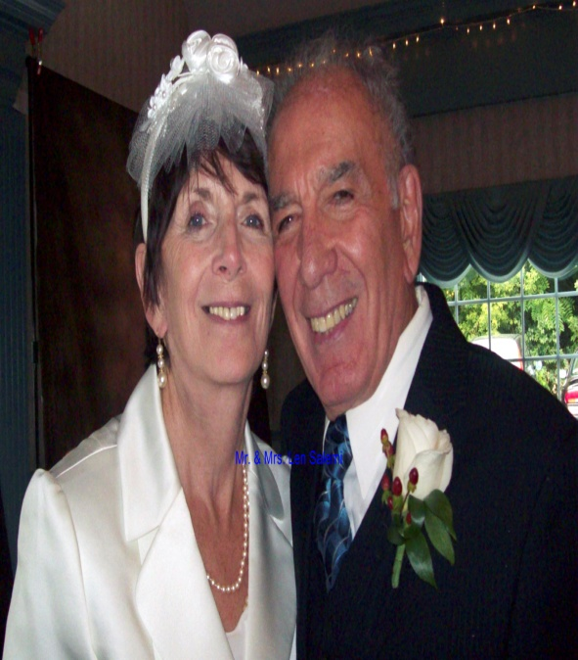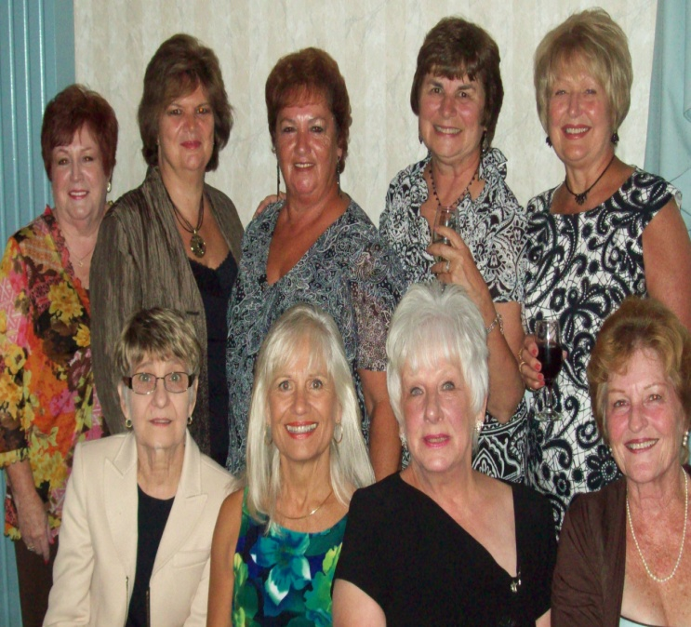

Since our reunion many classmates have re connected and have got together the past year. We had groups meet in Florida in Jan, Arizona during Da Cubs spring training and I am sure many, many other places. Some of us got to visit classmates we have not seen in many, many years. Our 50th reunion brought many of us back together again.

The Class of 1959 website – [www.leyden59.com](http://www.leyden59.com) has been kept in operation beyond the 50th reunion. Right now the website will be active until March of 2011, and we can keep it going indefinitely with news about our classmates, addresses, email information, travel plans and items of interest.

Our class directory is now totally digital and can be accessed via web page if you use web page sign up process. We will keep it as current as possible but requires your inputs on changes, etc.

Now that we have established communication with each other, don’t you think we should try to keep in touch? That’s one of the reasons for having our website stay open, so you can communicate with the rest of the Class of 1959.

Happily there were so many classmates at our 50 year reunion, but if we stay in touch we can have “mini reunions” for all the people that weren’t able to attend, whenever you come into Chicago or in your travels to other parts of the country. We're starting to talk about a BBQ/Picnic reunion for next year.  Maybe a pig roast..or we bring our own stuff for bbq'ng.  So far we've gotten pretty good responses.  Seems everyone would like a "casual/comfortable" day... not a sit-down dinner and all that stuff.  Just one day in the woods or a park somewhere to hang out for the day in our jeans & sneakers!! Whadda ya think???  This is in the VERY, VERY preliminary stage... I'm just sending some "feelers" out there.  Let me know what you think. Contact a committee member.

Until we meet again – wishing you good health – good times – good friends. Take care.

Joyce Owen Staerkel, Reunion Chairwoman 708 681-3623 cell: 630 247-5592

Len Hofmann, Webmaster 480 837-4927 cell: 480-358-5442

Email: [Jsstaerkel@aol.com](mailto:Jsstaerkel@aol.com)

Email: [lhofmann@cox.net](mailto:lhofmann@cox.net)

Web address: [www.leyden59.com](http://www.leyden59.com)